Chapter 4, Problem 90.

The Wheatstone bridge circuit shown in Fig. 4.146 is used to measure the resistance of a strain gauge. The adjustable resistor has a linear taper with a maximum value of 100 Ω. If the resistance of the strain gauge is found to be 42.6 Ω, what fraction of the full slider travel is the slider when the bridge is balanced?

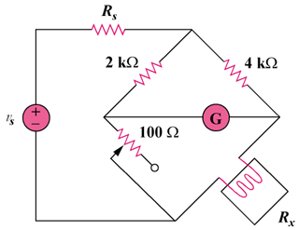

Figure 4.146
For Prob. 4.90.

